**Conventional and Addressable Fire Alarm Systems**

Fire alarm systems can be broken into two main categories. These are the original conventional systems and the modern addressable systems. Both of these systems include heat detectors, manual pull stations, smoke detectors and output alarms. The main differences occur in how the control panels receiver data and control these systems.

Prior to the twenty first century, the conventional system was the standard fire alarm system used in commercial building designs. The way these systems are designed is that each common area and floor will be organized into a large zone. Each zone is connected to one common circuit which is connected to the control panel for that zone. Along each circuit there will be many thermal sensors, smoke detectors, pull alarms and fire sensors. These devices would be placed strategically according to a variety of factors such as the type of anticipated emergency and how fast of a response is needed.

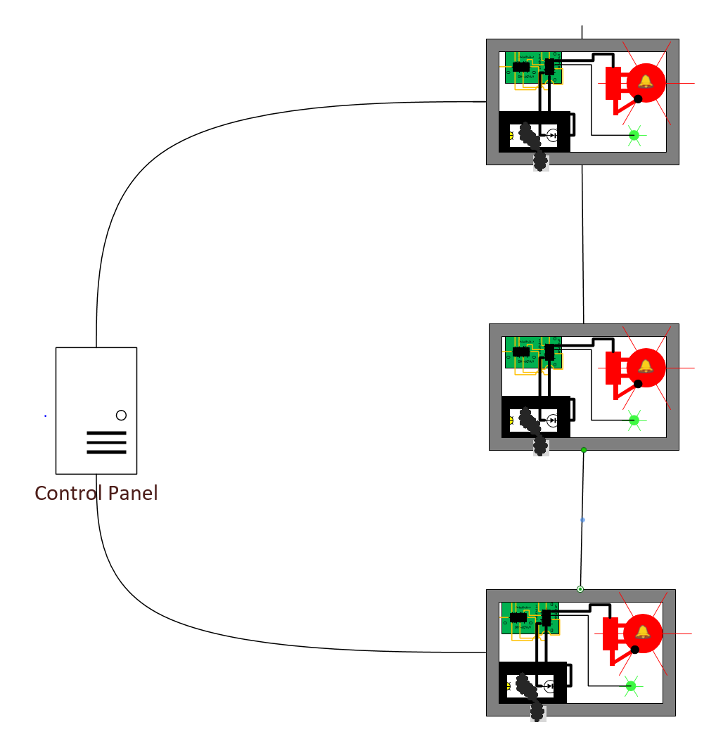

**Conventional System Diagram**

When an emergency occurs, one or more of the detectors and sensors will operate and essentially close the circuit. The control panel for the system will recognize that the circuit has been closed which would mean an emergency has taken place. All of the output devices for this system will be connected to their own circuit separate from the input devices. When the control panel detects that an emergency has occurred, the control panel will activate the output devices. This turns on all of the sound alarms for the building and call any emergency services.

There is a major downside to this type of system. Because each input device is connected to the same circuit, there is no way of knowing which input device actually detected an emergency. The control panel only knows that an emergency is taking place within its “zone.” This also is the case for monitoring the status of the system. In order to check that the system is functioning in top condition, the control panel would send a small current through the wires of the circuit. Should there be an issue with the system, such as a break in wiring, the current would not be able to proceed throughout the circuit. This would tell the control panel that there is an issue. The control panel would know that maintenance needs to be performed but there is no way of knowing exactly where. Because of the way the components are arranges, these systems are actually monitoring and controlling entire zones and not individual areas or devices.

There is one major advantage to conventional fire alarm systems, however. For small or intermediate sized buildings, these systems are easy to set up, configure, and install. Because they are just simple circuits, maintenance does not require a large amount of experience. This works in the opposite way for very large areas as they require a large amount of wiring to monitor the input devices.

Conventional systems do require a large amount of personnel maintenance, however. Each input device requires its own manual test in order to verify that it is in good working condition. Smoke detectors, for example, need to be checked and cleaned every now and again. With the conventional system, there is no way of easily knowing which smoke detectors need maintenance and which don’t. Therefor maintenance working need to go through and check every smoke detector during a maintenance check.

Addressable systems are the evolution and improvement of conventional systems. They are the state-of-the-art system used in today’s commercial building designs for emergency detection. The main difference between these systems and conventional systems is that these systems have the ability to control and track each device connected to the system. This is in contrast to conventional systems where each device is connected to the same circuit with the control panel only having control and tracking of an entire zone.

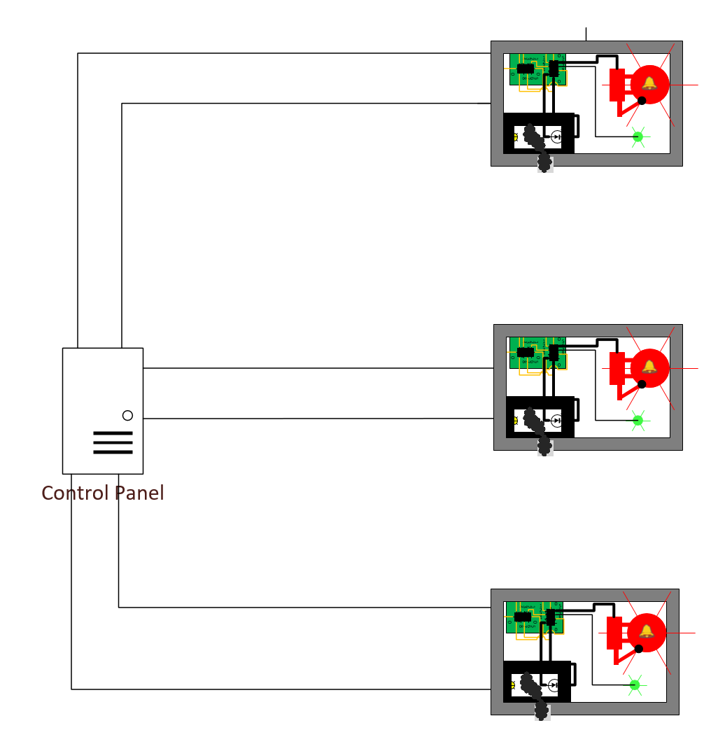

**Addressable System Diagram**

For the addressable system, each input and output device has its’ own microprocessor. This microprocessor tracks and controls the individual device that it is connected to. The microprocessors then send and receive signals from the control panel. This is the type of system that is going to be used for our design of the Smart Fire Alarm System. Each fire alarm for our project contains the ATmega 328 microprocessor.

Just like the conventional system, the addressable system also uses one circuit that goes throughout the entire building. Also just like the conventional system, one or more of these input devices may be connected to this single circuit. The big difference here is that for the addressable system, the way in which these devices are monitored is much different. In a normal addressable system, each input and output device is given its own “address” which is used to identify each device. These addresses are then programmed into the memory of the control panel along with information including the type of device that this address corresponds to, where the device is located, and details like when these devices should be checked for input or signaled for output.

For addressable systems, the control panel sends out a signal to each circuit that it is connected to. The devices also send out a signal back to the control panel. This allows for constant monitoring of each device. Every few seconds the control panel will receive an update from each device as to its status which will allow rapid response when an emergency occurs. Because of the addresses and locations, the control panel will also know which device is going off.

The control panel for this system also constantly monitors the condition of the devices connected to each circuit. This brings major improvements to maintenance for the system. Since each device has its own address and location stored in the control panel, the system can not only know when a fault occurs, but also where a fault occurs. This makes the job of the maintenance worker much easier. The maintenance worker now does not need to evaluate each and every device in order to provide maintenance to the system. The control panel can tell the maintenance worker exactly which device needs to be worked on. This allows for quicker and cheaper repairs for both the maintenance worker and the owner of the system.

Addressable systems also provide a much easier process for modifying the system and adding or removing components. For addressable systems it’s as easy as setting up the individual device and then configuring the control panel’s memory. The installer only needs to go to a computer connected to the control panel and insert information such as the address, location, and type of device into the system. For a conventional system, the maintenance worker has to work with the wiring of the circuit and edit electrical configurations. This is much more work than for the addressable system.

The one major disadvantage for the addressable systems, however, is that each system is a custom design. Each system has its own unique characteristics for how the memory and control panel does calculations and stores information in memory. This requires specially trained technicians who have knowledge in the exact configuration that is being used. While this may be a major disadvantage, it is greatly outweighed by the advantages that using a addressable system provides.